Department of Information Technology
Faculty of Computing
The Islamia University of Bahawalpur



Software Design Document
Real-Time Vehicle Detection, Classification, and Counting System Using Computer Vision and Deep Learning

Submitted by
Abdul Majid Ashraf
F22BINFT1E02058

Submitted to
Sir Faisal Shahzad

Summery
This project develops an ML-based real-time vehicle detection and classification system capable of identifying and counting vehicles from live video feeds. Using computer vision techniques and deep learning models such as YOLO, the system detects moving vehicles and classifies them into categories like cars, trucks, and buses. It also keeps a real-time count of each category, which can be used for traffic analysis and intelligent transport management. The system can operate on live CCTV footage or pre-recorded videos, enabling authorities to monitor traffic flow, detect congestion, and gather data for infrastructure planning.

Table of Content

1. Introduction 4
2. Application Architecture 4
2.1. Architectural Overview 4
2.2. High-Level Architecture Components 4
3. Data Model Schema 5
3.1. Overview 5
3.2. Entity Descriptions 5
3.3. Relationships 7
4. User Interface Design 7
4.1. UI Overview 7
4.2. UI Components 7
4.3. UI Interaction Flow 8
5. Non-Functional Design Considerations 8
5.1. Performance 8
5.2. Scalability 8
5.3. Maintainability 8
5.4. Security & Privacy 8
6. Design Diagrams 9
6.1. System Workflow Diagram 9
6.2. Component Interaction Diagram 9
6.3. Data Flow Diagram 10
7. Conclusion 10

- Introduction
This Software Design Document (SDD) provides a detailed design-level description of the system based on the approved Software Requirements Specification (SRS) for the project Real-Time Vehicle Detection, Classification, and Counting System Using Computer Vision and Deep Learning. The document explains how the system will be architected, how data will flow and be stored, how users will interact with the system, and how different components collaborate to fulfill functional and non-functional requirements.
The purpose of this SDD is to act as a technical blueprint for implementation, testing, and future enhancement of the system.

- Application Architecture
  - Architectural Overview
The system follows a modular, layered architecture consisting of four primary layers:

- Presentation Layer (User Interface)
- Application Layer (Controller & Logic)
- Machine Learning & Computer Vision Layer
- Data Layer

This architecture ensures scalability, maintainability, and clear separation of concerns.

  - High-Level Architecture Components
- Presentation Layer

  - Web-based dashboard or interface
  - Displays live video stream
  - Shows bounding boxes, labels, and real-time vehicle counts
  - Provides controls for video selection and monitoring

- Application Layer

  - Manages application logic and workflow
  - Handles user requests
  - Coordinates video streaming, model inference, and result visualization

- Machine Learning & Computer Vision Layer

  - YOLO-based deep learning model for object detection
  - OpenCV pipeline for video frame extraction and preprocessing
  - Real-time inference and classification logic

- Data Layer

  - Stores vehicle counts and detection statistics
  - Manages optional logs or historical traffic data
  - Supports future analytics and reporting modules

Architectural Flow

- Video input is captured from CCTV or uploaded files
- Frames are extracted using OpenCV
- Preprocessed frames are passed to the YOLO model
- Results are sent to the UI for visualization
- Results are displayed to the user
- Vehicle counts are updated in real time

- Data Model Schema
  - Overview
The data model defines how detection results, vehicle counts, and optional logs are structured and managed within the system. The system is primarily real-time and does not heavily rely on persistent storage, but structured schemas ensure extensibility.

  - Entity Descriptions
    - Video Source
Attribute | Description
source_id | Unique identifier for video source
source_type | Live CCTV or Recorded Video
source_path | File path or steam URL
status | Active or Inactive

    - Frame
Attribute | Description
frame_id | Unique frame identifier
timestamp | Capture time
resolution | Frame Size
processed | Processing status

    - Vehicle Detection
Attribute | Description
detection_id | Unique detection ID
vehicle_type | Car, Truck, Bus
confidence_score | Detection confidence
bounding_box | Coordinates of detected object
frame_id | Associated frame

    - Vehicle Count
Attribute | Description
vehicle_type | Category of vehicle
count | Total detected vehicle
timestamp | Time of update

  - Relationships
- One VideoSource produces multiple Frames
- One Frame can contain multiple Vehicle Detections
- Vehicle Detections update the Vehicle Count entity

- User Interface Design
  - UI Overview
The user interface is designed to be intuitive and accessible for users without technical expertise in AI or computer vision. The interface focuses on clarity, real-time feedback, and ease of navigation.

  - UI Components
    - Dashboard Screen
- Live video display panel
- Bounding boxes and labels over detected vehicles
- Real-time vehicle count summary
    - Control Panel
- Start/Stop video stream
- Upload recorded video
- Switch between multiple feeds
    - Analytics SectionUser opens the web interface
- Vehicle count per category
- Traffic flow insights
- Optional historical summaries

  - UI Interaction Flow
- User opens the web interface
- User selects a live feed or uploads a video
- System starts detection automatically
- Results are displayed in real time
- Vehicle counts update dynamically

- Non - Functional Design Considerations
  - Performance
- Optimized frame processing
- GPU acceleration (if available)

  - Scalability
- Modular design supports multiple video feeds

  - Maintainability
- YOLO model can be updated independently
- Easy addition of new vehicle categories

  - Security & Privacy
- Secure handling of video streams
- No unnecessary storage of sensitive footage

- Design Diagrams

  - System Workflow Diagram

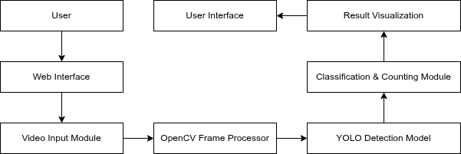

  - Component Interaction Diagram

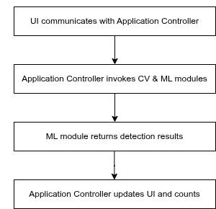

  - Data Flow Diagram

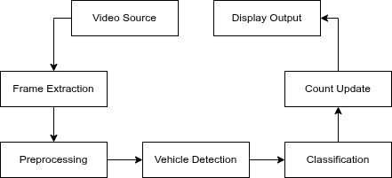

- Conclusion
This Software Design Document provides a complete technical design for implementing the real-time vehicle detection, classification, and counting system. The proposed architecture, data models, interface design, and workflow ensure that the system meets all functional and non-functional requirements defined in the SRS. The design is scalable, maintainable, and suitable for real-world intelligent traffic monitoring applications.

